**Aligning molecular and microscopy methods in detecting kelp biofouling in plankton and blade surfaces**

**Introduction**

Macroalgae cultivation offers significant potential as a sustainable marine bioresource, capable of advancing global food security, mitigating climate change and delivering high-value products across medical, agricultural and industrial sectors (Sultana et al., 2023, Jagtap and Meena, 2022, Duarte et al., 2021). Although Asian producers have long dominated global seaweed markets, emerging expansion within regions like the North-East Atlantic demonstrates the rising international interest for macroalgae production (Veenhof et al., 2024, Zhang et al., 2022). Seaweed farming is critical to the EU’s sustainable blue economy which aims to increase production to 8 million tonnes by 2030, creating 85,000 jobs and generating an estimated 9 billion Euros of revenue (Jueterbock et al., 2025). However, there are significant barriers to commercial viability for Europe’s seaweed industry which is predominantly made up of small-scale startups (Addamo et al., 2022). Limitations in infrastructure, high productions costs and inconsistent biomass qualities that meet market demand hinder industry expansion and broader market access (Holland and Shapira, 2024).

Another major constraint to commercial profitability is the significant and destructive impact of proliferating biofouling organisms upon farmed seaweed (Bannister et al., 2019). The same cold, mesotrophic conditions that make North-East Atlantic coastlines suitable for seaweed mariculture also favour rapid seasonal growth of harmful epibionts which colonise seaweed blades (Forbord et al., 2020). Biofouling taxa include bryozoans, hydrozoans, gastropods, amphipods, gastropods and bivalves exert varying impacts to both wild and cultivated seaweed populations (Matsson et al., 2019). Physical damage to fronds, physiological disruptions and competition for keys resources by biofouling organisms collectively impact afflicted seaweed (Walls et al., 2017). Fouling colonies such as encrusting bryozoans shade and block fronds; impairing photosynthesis and reproductive spore release and can ultimately result in tissue necrosis (Bannister et al., 2019). Epibiont coverage reduces blade flexibility and subsequent increases hydrodynamic drag which increases susceptibility to breakage, dislodgement and reduced overall yield (Krumhansl et al., 2011). As biofouling intensifies, the commercial value of seaweed declines due to deterioration in frond quality and taste, increased biomass waste, and heightened allergen risk consumers (Walls et al., 2017, Bannister et al., 2019).

Skye : Kelpcrofting

eDNA : metabarcoding

Integrated analysis of molecular data alongside physical observations enables investigation into the temporal lags between meroplanktonic larvae within the water column and their subsequent physical settlement upon the seaweed substrate. While metabarcoding has proven effective in community composition studies, its potential as a tool for early detection is increasingly evident as it offers broad taxonomic resolution and ability to detect often overlooked or cryptic species. However, with metabarcoding, challenges remain in detection inconsistencies, particularly in low abundance species due to amplification biases caused by primer selectivity (Algueró‐Muñiz et al., 2024). By aligning molecular reads with visual observations such as planktonic counts and blade colony assessments, it becomes possible to generate a more holistic understanding of biofouling dynamics. Collectively, this can improve the accuracy and reliability in using molecular read data within biofouling monitoring frameworks.

**Methods**

*Site and Sampling: Farm layout, coordinates*

*Saccharina and Alaria*

*Plankton Microscopic Surveys*

*Microscopic Identification of Blade Epibionts*

*DNA Extraction and Species Identification*

A total of 24 epibiont specimens were collected from Kelpcrofters Seaweed Farm (Isle of Skye) between June 2021 and January 22. Samples were preserved in 95% ethanol and stored at -20oC until processing. Genomic DNA was extracted using Qiagen DNeasy® Blood and Tissue Kit according to manufacturer’s protocol. Extracted DNA was quantified with a Qubit™ Fluorometer and diluted to a concentration of 1.3ng/μl prior to submission for Sanger sequencing (University of Dundee) Resulting sequences were trimmed and aligned using BioEdit Sequence Alignment Editor. Taxonomic identification was performed through BLAST searches within the NCBI GenBank database, using criteria of ≥97% sequence similarity, amplicon lengths >80 bp, and the lowest E-value for species assignment. Sequences that failed to meet these criteria were omitted. Identified taxa were subsequently compared with results from visual surveys conducted using a stereomicroscope.

*Data Analysis*

We combined eDNA metabarcoding, plankton‐net microscopy counts, and visual surveys of blade‐attached epibionts to undertake both descriptive and comparative analyses addressing three core objectives: 1) Method comparison: Quantify and contrast the sensitivity and taxonomic resolution of molecular (eDNA) versus microscopy‐based approaches in detecting epibionts both in the water column and on kelp blades. 2) Temporal dynamics: Characterize time‐lags among eDNA signal emergence, planktonic epibiont detections, and their subsequent settlement on seaweed fronds. 3) Depth distribution: Evaluate how epibiont colonization intensity varies along blade depth gradients. Figure 1 represents the combined methodological framework utilized within this study.

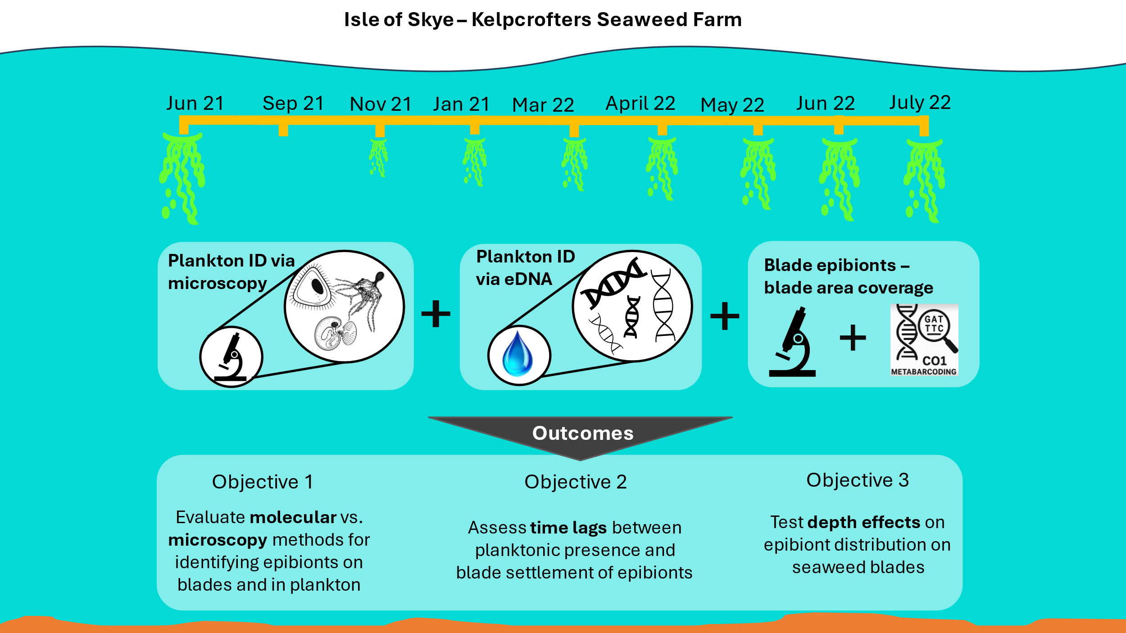

**Figure 1**. Methodological Framework: Overview of the study approach and outcomes

**Results**

*Molecular vs. microscopy methods for identifying epibionts on blades and in plankton*

Metabarcoding analysis and microscopic identification revealed several epibiont species commonly associated with seaweed cultivation (*Table 1*). In most cases, identification of epibiont taxa was achieved only to the resolution level of order (e.g. Amphipoda/Hydrozoa). Several of the epibionts were identified on the blades via rope scrubbing, a method that involved scraping biofouling organisms from cultivation ropes that are submerged in the water column prior to macroalgal seeding. This temporal relationship indicates that epibionts may colonise farm ropes and remain there until blades have grown to a suitable size for colonisation. Farming operations may benefit from cleaning ropes or removing lines from the sea altogether prior to seeding to mitigate their reservoir/vector effect.

Planktonic identification of species is always difficult due to the often-fragmented form of samples as well as the strong morphological similarities among species and life-stages. However, the integrated use of DNA barcoding and BLAST sequence analysis provided considerably enhanced taxonomic resolution. For example, *Hiatella arctica* and *Celleporella hyalina* were confidently identified from high-percentage barcode matches, despite limited plankton identification. This molecular approach not only corroborated physical detection methods but also provided insight into species that may otherwise go unnoticed using microscopy alone. Overall, integrating visual data with barcoding reveals key species affecting seaweed farms and ultimately advances the understanding of biofouling dynamics.

Table 1. Summary of epibiont taxa identified and the highest taxonomic resolution achieved by each method: visual identification from blades, planktonic microscopy surveys, and DNA barcoding. Percentage value (%) denotes percentage identity match of sequence with with GenBank database. Rope scrub presence (Y/N) denotes taxa identification from scrubbing of farm ropes prior to seaweed seeding.

|  |  |  |  |  |
| --- | --- | --- | --- | --- |
| Epibiont ID | Plankton ID | Barcode ID | Rope Scrub Presence | Photo |
| Amphipoda (Caprellidae) | NA | *Caprella mutica* (100%) | Y |  |
| Amphipoda (Caprellidae) | NA | *Jassa herdmani* (100%) | Y |  |
| Amphipoda (Jassa) | NA | *Jassa herdmani* (100%) | Y |  |
| Bryozoans (cf Celleporella hyalina) | Cyphonaute | *Celleporella hyalina* (98.79%) | N |  |

|  |  |  |  |  |
| --- | --- | --- | --- | --- |
| Epibiont ID | Plankton ID | Barcode ID | Rope Scrub Presence | Photo |
| Clam juvenile | Bivalvia | *Hiatella arctica* (97.7%) | Y |  |
| Dendronotid sea slug (Doto) | Gastropod | *Doto coronata* (99.62%) | Y |  |
| Electra pilosa | Cyphonaute | *Electra pilosa* (97.3%) | Y |  |
| Hydroid (Tubulariidae) | NA | *Ectopleura larynx* (100%) | Y |  |
| Hydroid (with Licmophora attached) | NA | *Bougainvillia muscus* (99.41%) | Y |  |

|  |  |  |  |  |  |
| --- | --- | --- | --- | --- | --- |
| Epibiont ID | Plankton ID | Barcode ID | Rope Scrub Presence | | Photo |
| Hydroid (with Licmophora attached) | Clytia sp. | *Clytia hemisphaerica* (99.59%) | | Y |  |
| Hydroid (with Licmophora attached) | NA | *Bougainvillia muscus* (99.41%) | | Y |  |
| Hydroid (with Licmophora attached) | Clytia sp. | *Clytia hemisphaerica* (99.59%) | | Y |  |
| Membranipora membranacea | Cyphonaute | *Membranipora membranacea* (99.60%) | | N |  |
| NA | Balanoid nauplii | *Amphibalanus improvisus* (100%) | | N |  |

|  |  |  |  |  |
| --- | --- | --- | --- | --- |
| Epibiont ID | Plankton ID | Barcode ID | Rope Scrub Presence | Photo |
| Obelia sp. | Obelia sp. | Obelia dichotoma (99.67%) | N |  |
| Rhodophyta (Pterosiphonia spinifera) | NA | Pterothamnion plumula (98.86%) | Y |  |
| Unidentified | NA | Laminaria digitata (99.6%) | Y |  |
| Unidentified algae (with Licmophora attached) | Hydroid | Bougainvillia muscus (99.41%) | Y |  |

*Assessment of time lags between eDNA , plankton and blade settlement of epibiont taxa*

*Bryozoa*

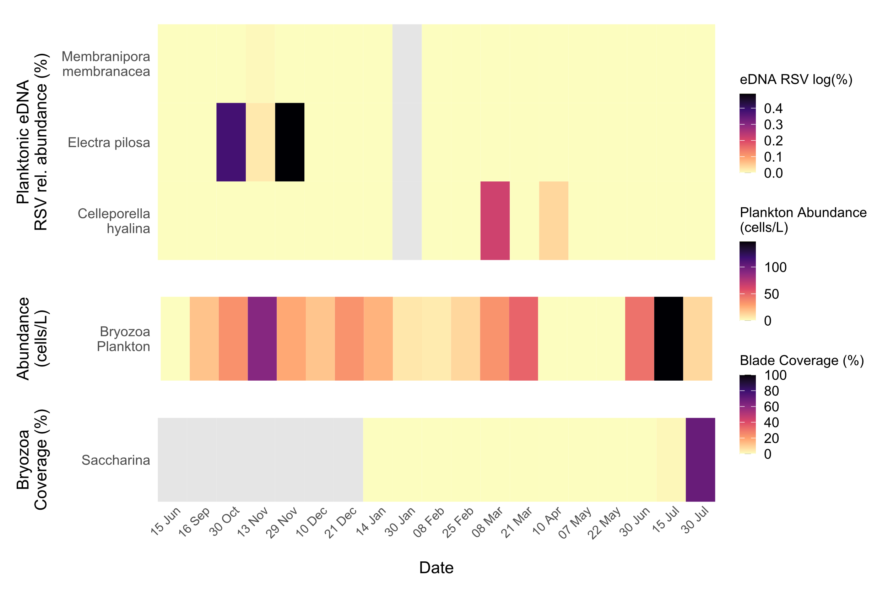

**Figure 2**. Temporal dynamics of Bryozoa epibionts. Heatmaps showing the seasonal patterns of bryozoan detection by eDNA metabarcoding, plankton microscopy, and blade settlement on cultivated kelp. Colours indicate log-transformed relative sequence variant (RSV) abundances (%), plankton cell counts (cells/ L); and percent coverage (%) of bryozoan colonies on Saccharina blades. No blade dectections of bryozoan species were recorded on Alaria. Sampling dates span 15 Jun 2021 to 30 Jul 2022. All values are monthly averages calculated from three independent replicate samples per date.Grey shading marks data unavailable.

*Hydrozoa*

**Figure 3.** Heatmaps showing the emergence and settlement of Hydrozoa detected by eDNA metabarcoding, plankton microscopy, and blade fouling on two kelp hosts. Colour intensity represents relative abundance of log RSV (%) from eDNA read samples, plankton abundances (cells/ L); and percent blade coverage (%) measured separately on Saccharina and Alaria. Sampling dates span 15 Jun 2021 to 30 Jul 2022. All values are monthly averages calculated from three independent replicate samples per date.Grey shading marks data unavailable

**Figure 4.** Heatmaps illustrating bivalve detection and colonization over time by relative abundance of eDNA RSV log (%) in the water column, plankton microscopy counts (cells/ L), individual density (ind/cm²) on Saccharina blades, and individual density on Alaria blades. All values are monthly averages calculated from three independent replicate samples per date. As before, sampling dates run from mid-June 2021 to end-July 2022, and grey bars indicate periods without data.

*Amphipoda*

**Figure 5.** Heatmaps representing seasonal patterns of amphipod detection and settlement by eDNA metabarcoding (log RSV %), plankton‐net microscopy counts (cells/L ), and blade colonization abundance (individuals/cm²) on Saccharina and Alaria fronds. All values are monthly averages calculated from three independent replicate samples per date. Sampling dates span mid-June 2021 to late-July 2022, and the grey-shaded areas mark indicate periods without data.

*Gastropoda*

**Figure 6** Heatmaps illustrating seasonal emergence and settlement of gastropods detected by eDNA metabarcoding (RA log RSV %), planktonic abundance (cells/L), and blade settlement abundance (individuals cm⁻²) on Saccharina blades. All values are monthly averages calculated from three independent replicate samples per date. Sampling dates run from mid-June 2021 through late-July 2022, and grey shading denotes periods without data.

*Temporal Composition of dominant zooplankton taxa*  
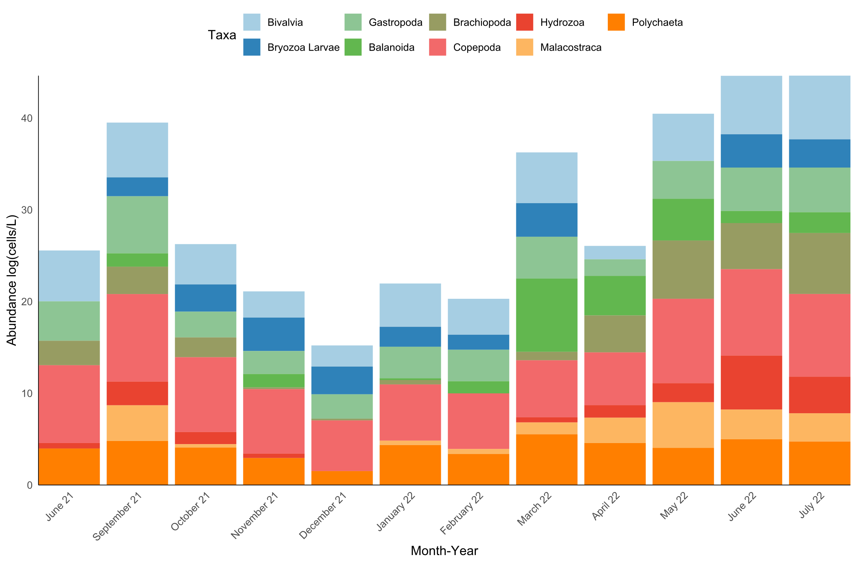

**Figure 7**. Stacked bar chart showing the mean monthly log-transformed abundances (cells/ L) of the principal planktonic groups collected by plankton net from June 2021 through July 2022 from Pabay, Isle of Skye. Coloured segments indicate contributions from Copepoda, Malacostraca, Polychaeta, Bivalvia, Bryozoa larvae, Gastropoda, Brachiopoda, Hydrozoa, and Balanomorpha (see legend). Seasonal shifts in community composition are evident in the varying heights and segment proportions of the monthly bars.

*Biofouling blade coverage of Alaria and Saccharina*

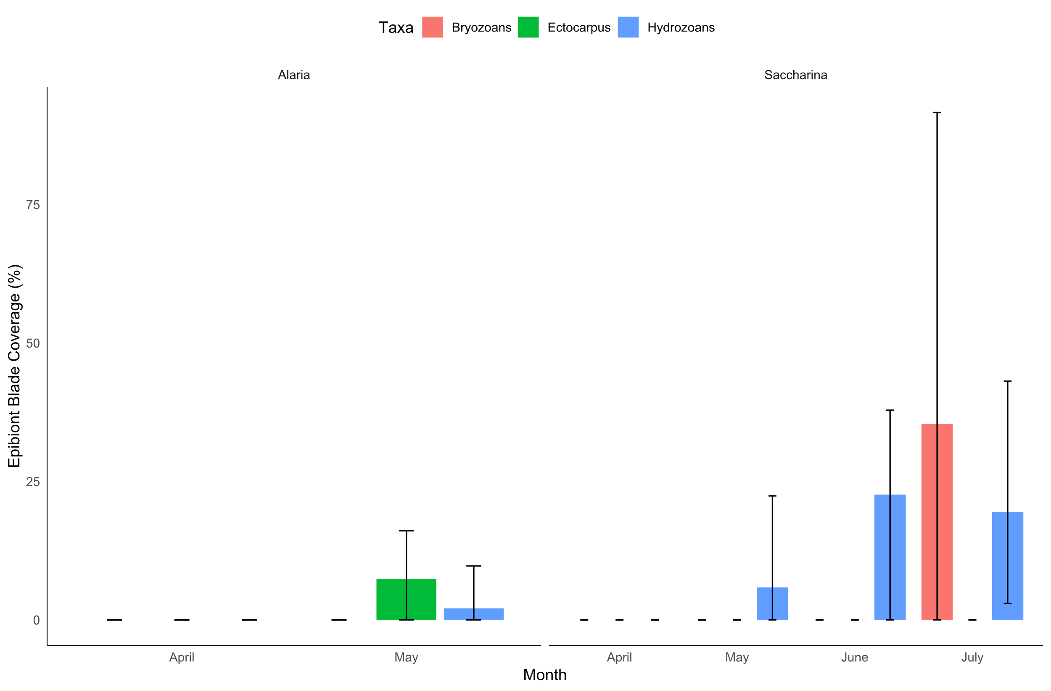

**Figure 8.** Bar charts showing mean percent blade surface covered by three epibiont groups—Bryozoans (red), Ectocarpus (green), and Hydrozoans (blue)—from April through July 2022. Error bars extend from the minimum to maximum observed coverage across replicate blades. Alaria fouling only recorded in May (no June or July data available), whereas Saccharina exhibited negligible coverage in April–May followed by substantial hydrozoan and bryozoan colonization in June–July.

*Biofouling blade colonisation of Alaria and Saccharina*

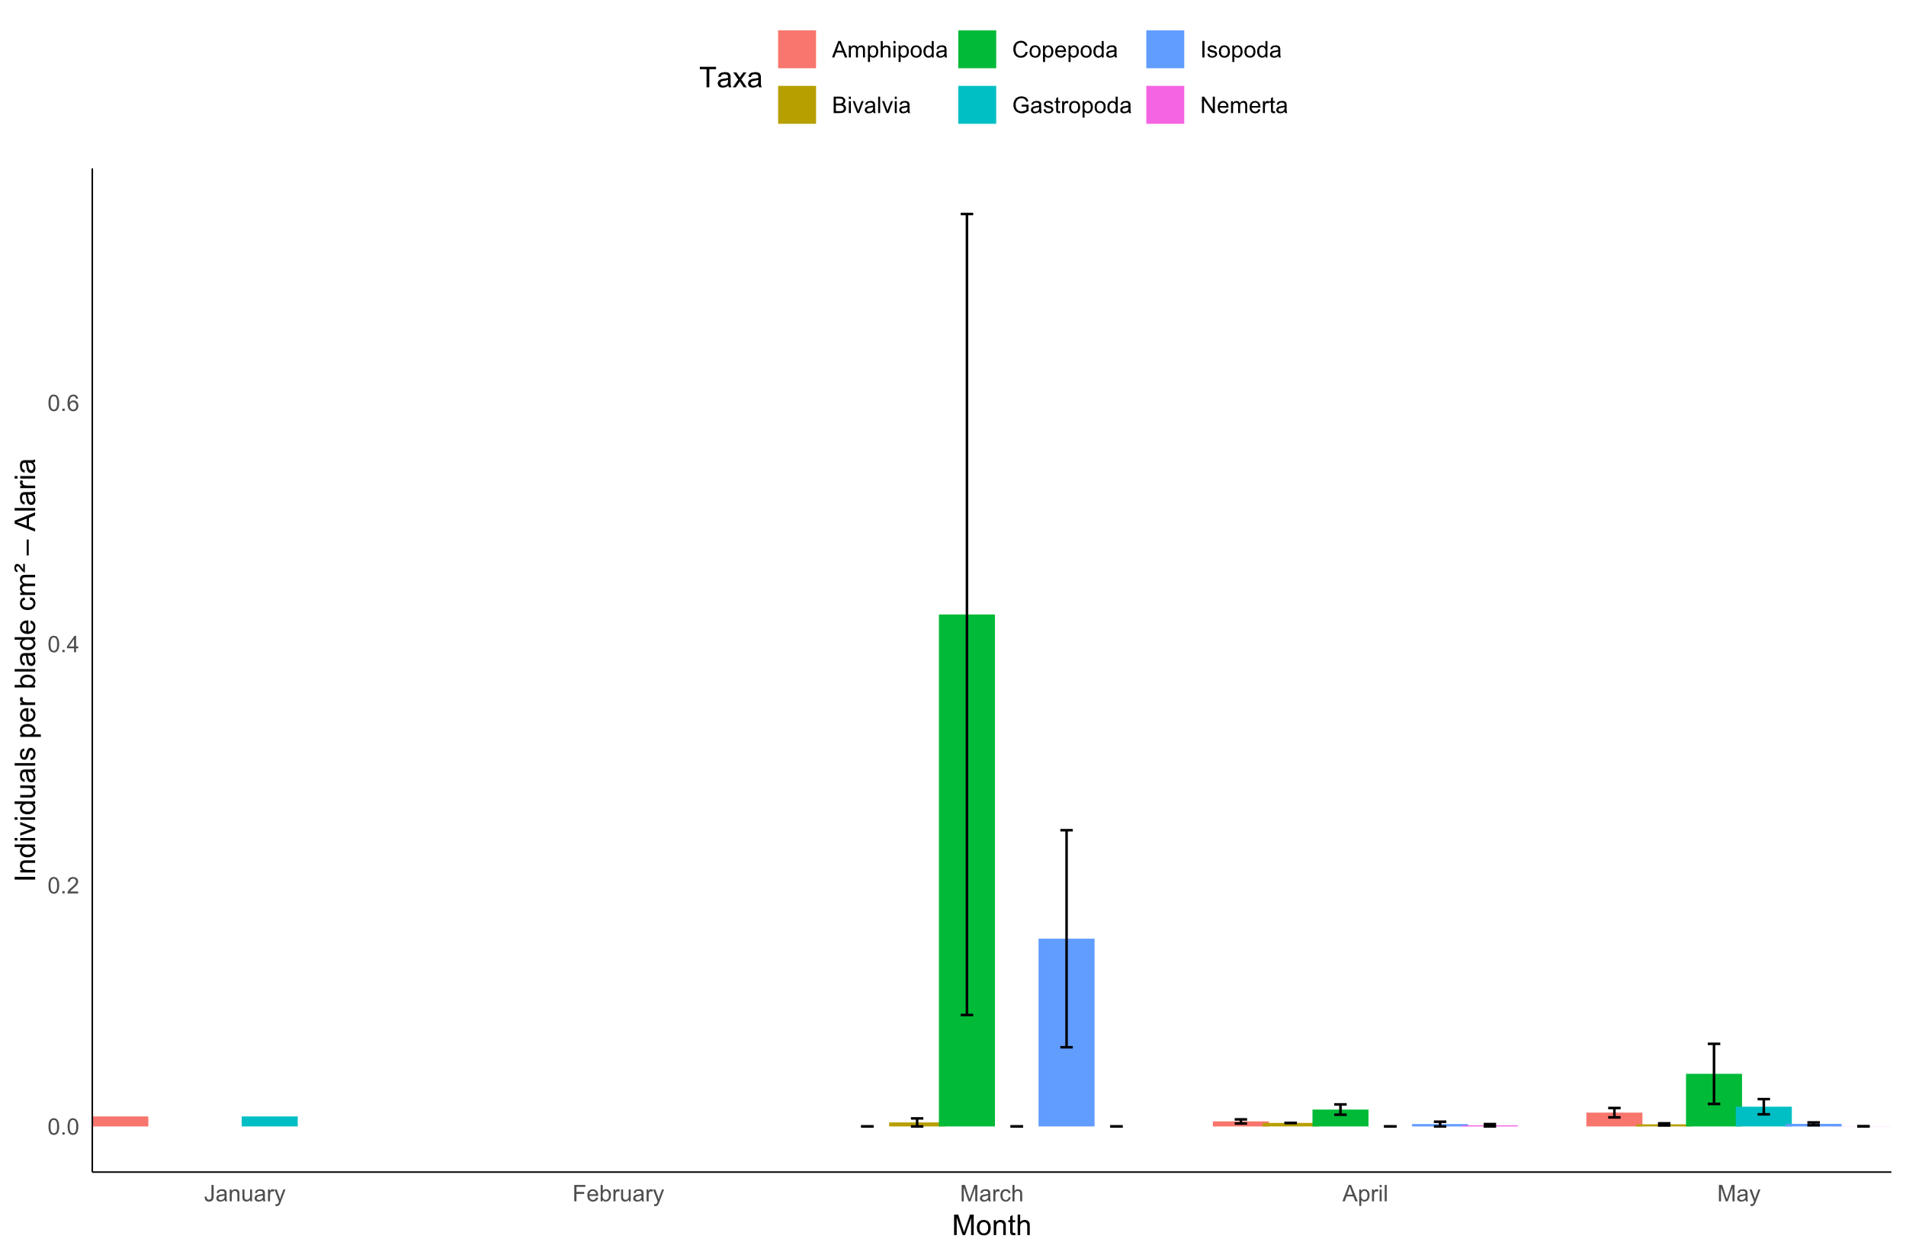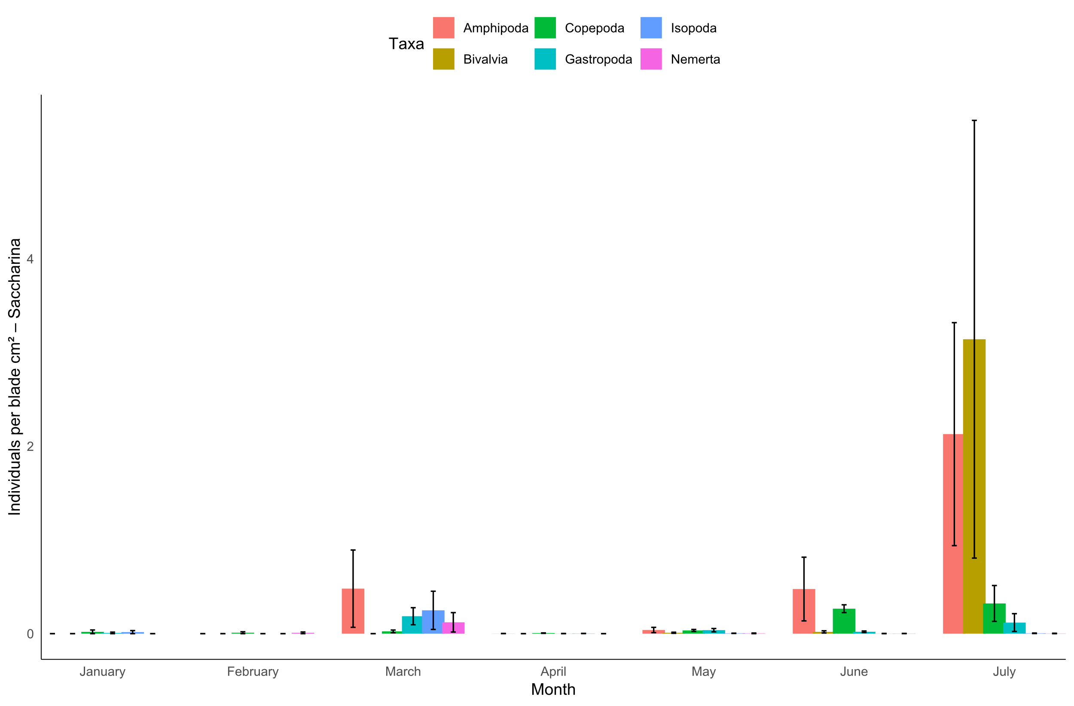

Figure 9. Bar charts showing mean colonization density (individuals /cm²) of six major taxa—Amphipoda (red), Copepoda (green), Isopoda (blue), Bivalvia (gold), Gastropoda (teal), and Nemertea (magenta)—on Alaria (top) and Saccharina (bottom) blades from January to July 2022. Error bars span the minimum to maximum values among replicate blades. On Alaria, peak copepod and isopod settlement occurs in March, with negligible densities before and after; on Saccharina, low-level settlement from January–June is followed by more pronounced amphipod and bivalve colonization in July.

*Depth effect on epibiont distribution on seaweed blades*

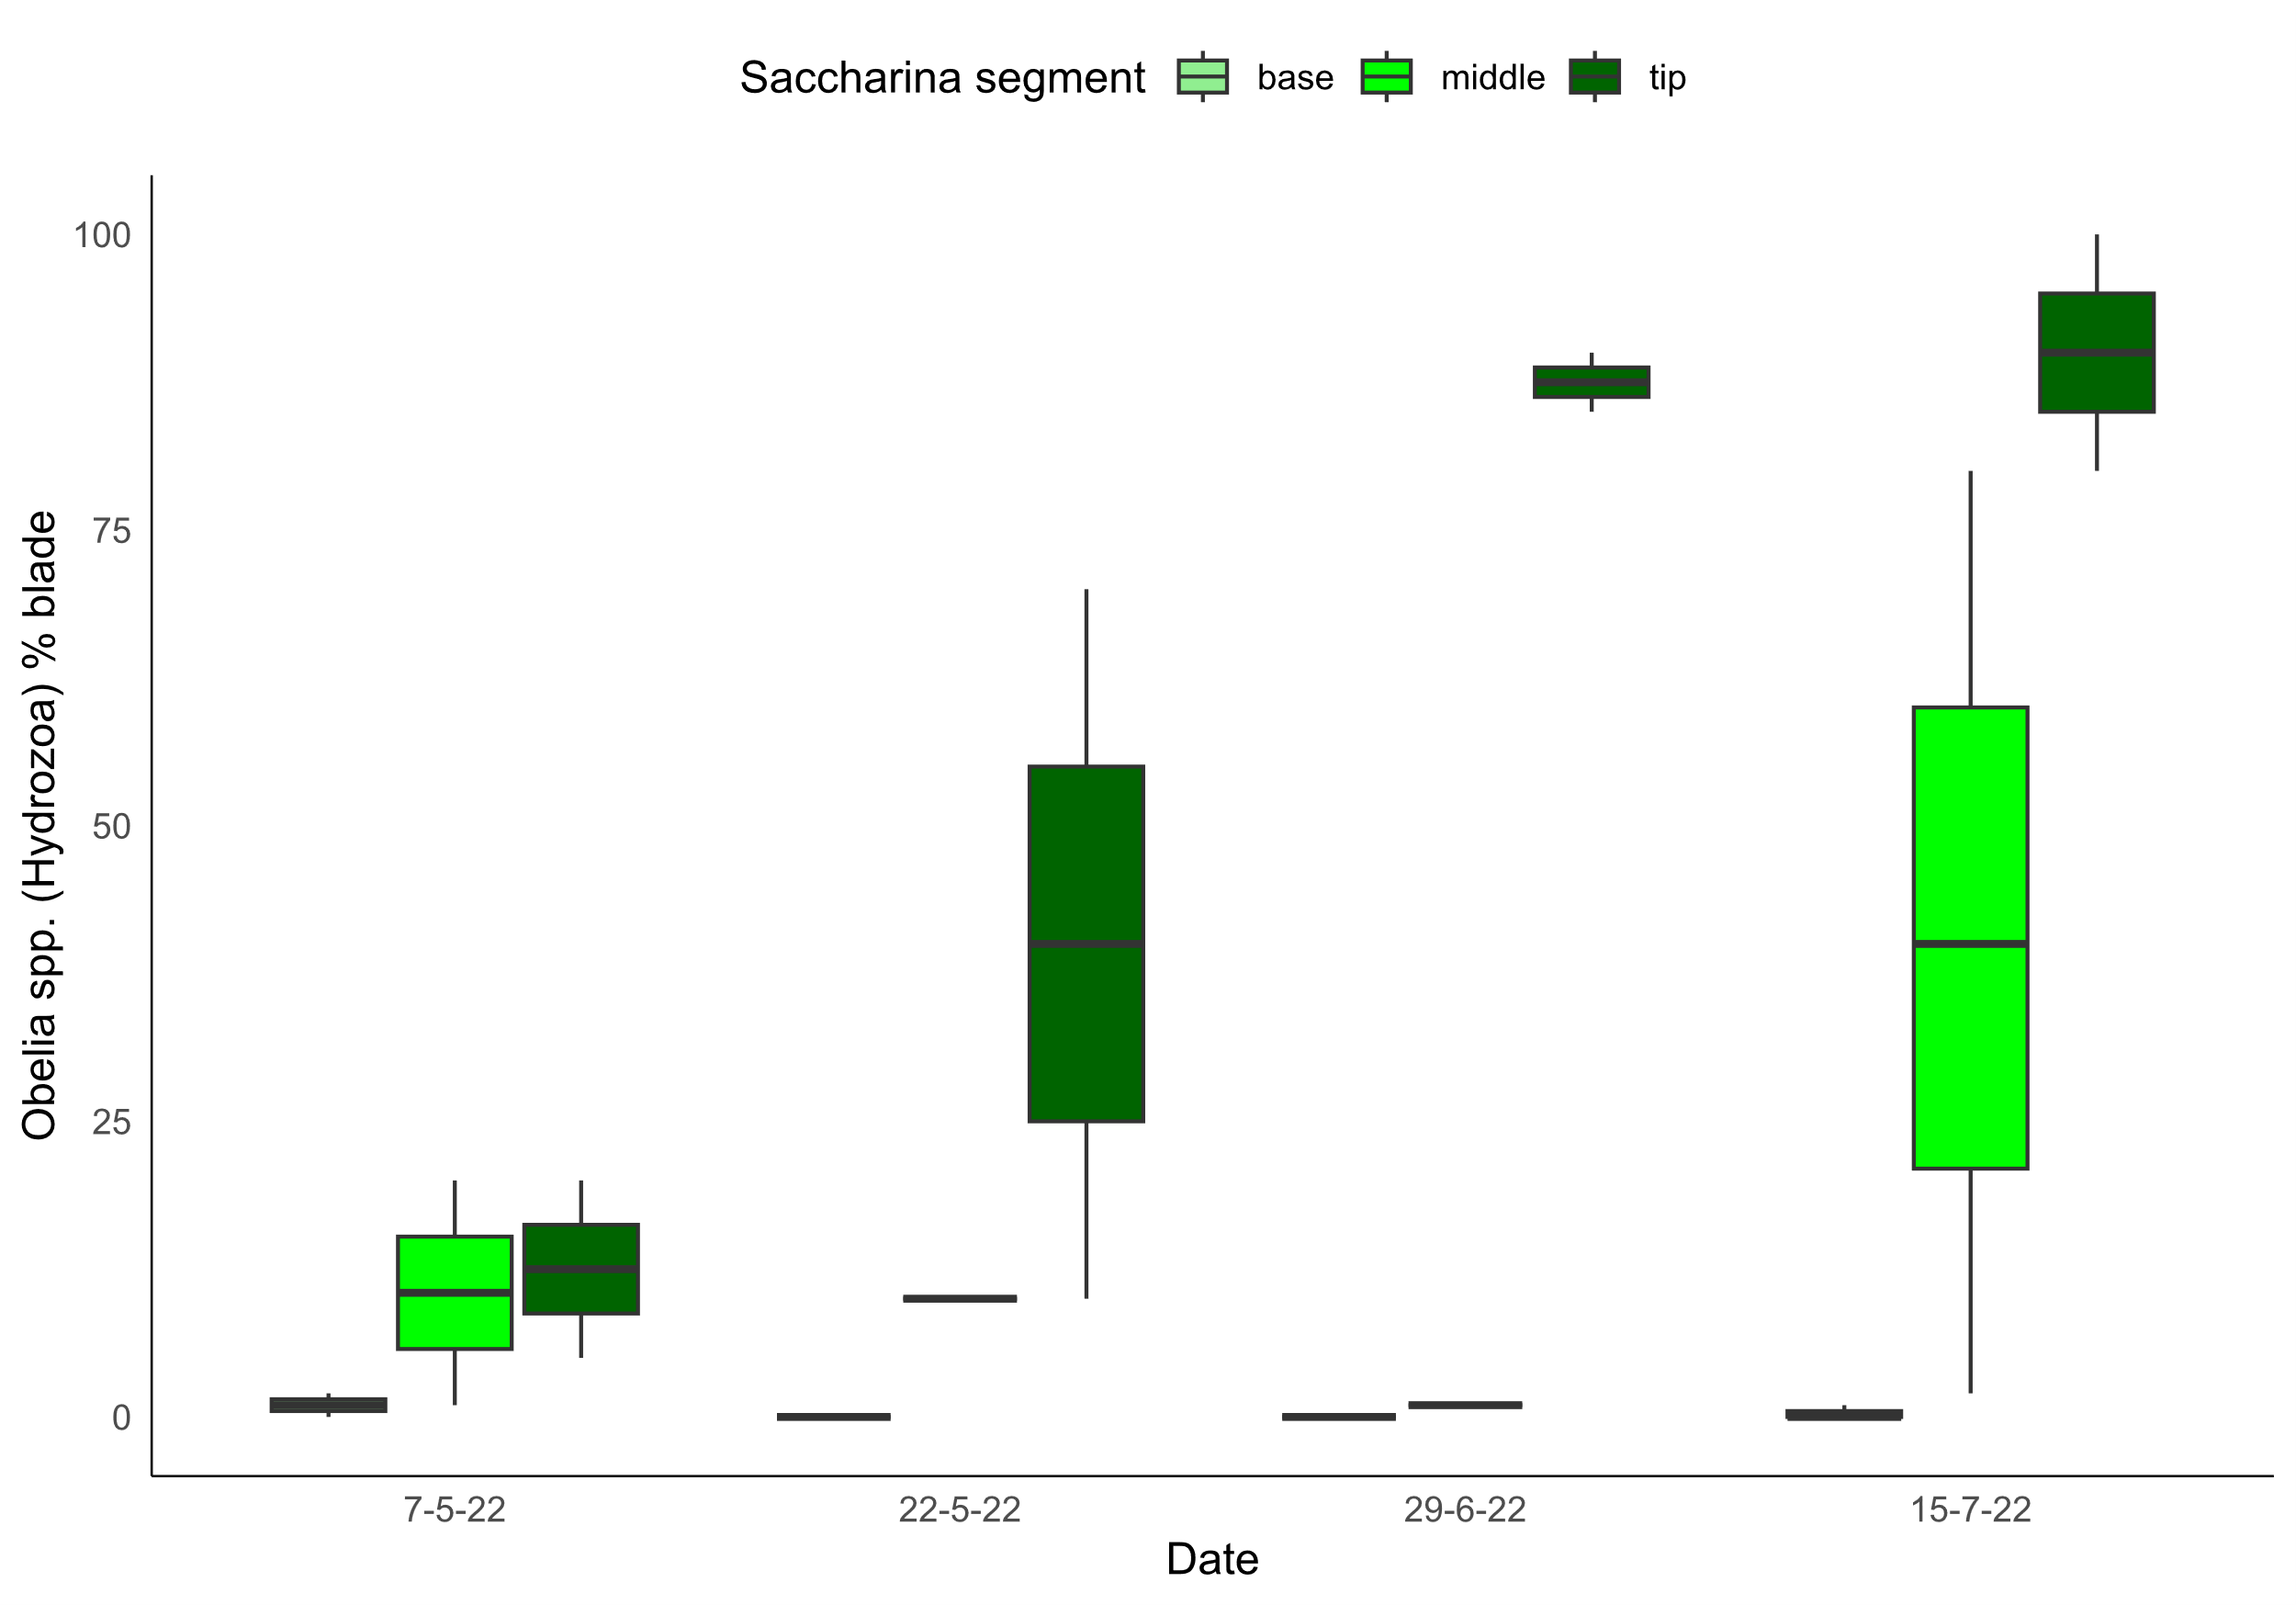

**Figure 10.** Boxplots of the percentage of blade area covered by Obelia spp. (Hydrozoa) on three blade segments—base (light green), middle (green), and tip (dark green)—sampled on 7 May, 22 May, 29 June and 15 July 2022. Colonization was essentially zero on the basal segment throughout the season, appeared first and most moderately on the mid‐blade by late May (median ~12 %), and quickly surged on the tip segment, rising from ~30 % coverage in late May to >85 % by late June and nearly complete (>90 %) by mid‐July. This pattern highlights both the rapid seasonal increase in hydrozoan fouling and the strong depth‐related gradient of epibiont settlement along the kelp blade.

Two-way ANOVA showed that hydrozoan coverage was significantly influenced by blade segment depth (F₂,₁₉ = 12.93, *p* < 0.001) and also varied significantly across sampling dates (F₃,₁₉ = 3.44, *p* < 0.05). This suggests that sugar kelp biofouling activity by *Obelia sp.* is driven by depth and time. This may be due to colonisation being favoured by a more stable water column microenvironment. For example, reduced light penetration, turbulence and potentially higher nutrient availability may contribute to hydrozoan proliferation. Segments deeper in the water column would have less mechanical disturbance from wave action further enabling sustained polyp growth.

Furthermore, seaweed growth occurs as the base/meristem while older tissue at the tips continually sheds (Mann, 1973). The distal blade segment represents the oldest, most established surface. The increased colonisation at the tip may be resultant from the tissue being more withered or structurally compromised due to longer exposure to environmental stressors thus heightening susceptibility to infestation. More simply, the tip section of the frond has existed the longest and therefore has had the greatest exposure time, providing more opportunities for settlement events and colony expansion. These combined physical and biological factors offer a plausible explanation for the consistently higher levels of biofouling observed at the blade tips. However, further targeted investigation is needed to disentangle the relative contribution of each factor and determine whether a single dominant driver or a synergistic combination is primarily responsible for hydrozoan colonisation patterns.

**Discussion**